Trial Trentini: Cappato and Welby were acquitted by the Massa Court of Appeal

Press release 27 07 2020 by Associazione Luca Coscioni

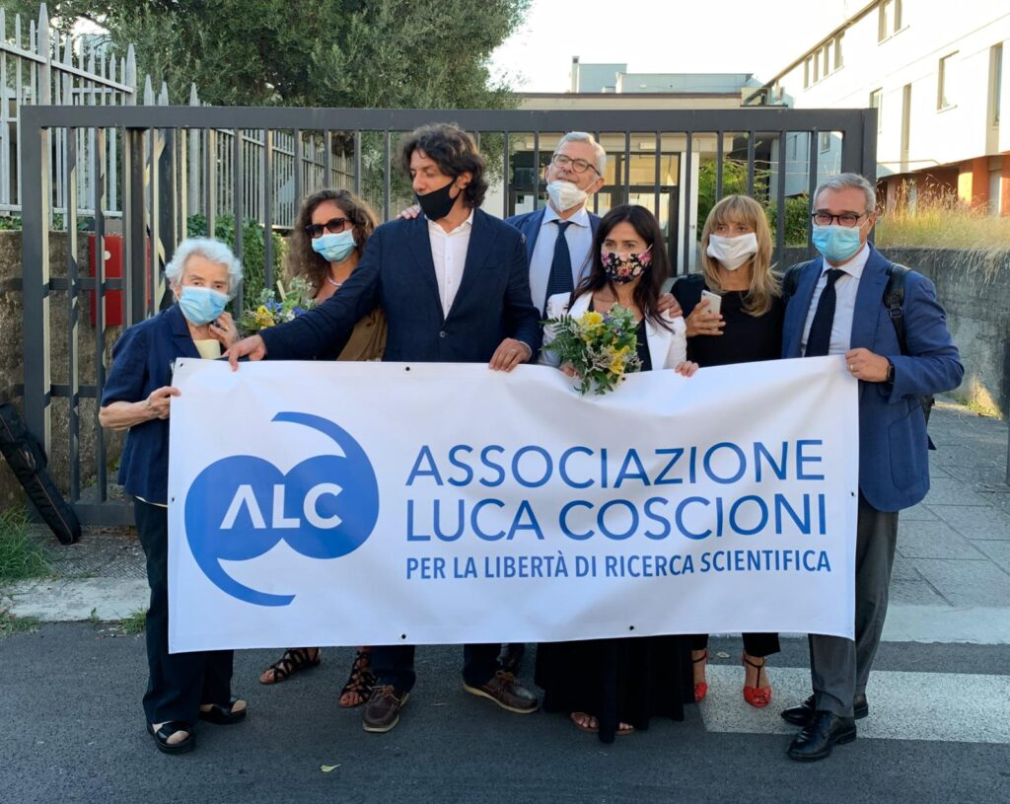
Marco Cappato and Mina Welby declare: "Our civil disobedience continues until the Parliament decides to legalize euthanasia".

Filomena Gallo, national secretary of the Associazione Luca Coscioni and coordinator of the counsel of lawyers which defends Marco Cappato and Mina Welby, comments on the judgment of the Trentini trial: “The decision is important because it clarifies that the requirement regarding the presence of life-support treatments is not limited to the mere presence of machinery ".
Mina Welby and Marco Cappato were acquitted by the Court of Appeal of Massa of the accusation of instigation and assistance to suicide for the death of Davide Trentini, because the fact does not exist regarding the instigation to commit suicide (article 580 of the Penal Code) and because the fact does not constitute a crime in the light of the judgment of the Constitutional Court 242/19 *), for the assistance provided to Davide Trentini. This was the decision of the judges of the Court of Massa, at the end of the hearings, in which the Public Prosecutor had asked for a 3-year and 4-month prison sentence.
"Today's ruling, in presence of the Parliaments’ indifference, is another step forward towards a wider recognition of the right to be assisted in dying," said Marco Cappato and Mina Welby, "Our action of civil disobedience will continue until the Parliament has decided to discuss the popular initiative proposal of law **)for legalizing the euthanasia, discussion that has been waiting for 7 years ".
The Court of Appeal of Massa was called to evaluate the facts prior to the Constitutional Court ruling no. 242/19, which legalized assistance to suicide under specific conditions.
"The Court today has recognized that the assistance provided to Davide Trentini, 53, suffering from multiple sclerosis since he was 27, does not constitute a criminal fact within the contest of the sentence 242/19 of the Constitutional Court," declared Filomena Gallo.
"It has been recognized that Davide Trentini therefore possessed all the requirements envisaged by the Constitutional Court's judgment 242/19 which makes it “not punishable who facilitates the suicide intention of the patient, independently and freely developed, by a person, fully capable to make free and conscious decisions, kept alive by life supporting treatments and suffering from an irreversible pathology, source of physical or psychological suffering which he considers intolerable.
“It is an important decision because it clarifies that the requirement for the patient to have life-supporting treatments is not limited to the presence of machinery only but also includes pharmacological treatments and assistance as in the case of Davide as demonstrated by the technical survey presented during the trial. We wait for the motivations to comment the judgement more into detail. However, we want to remember that once again it are the judges who affirm fundamental freedoms before the legislation by the Parliament, which, despite the invitation of the Constitutional Court to issue a law that legalizes all end-of-life choices, has not even started the discussions ".
"Today has won the Constitution regarding the rights and freedoms of many patients who, following the Constitutional Court ruling, now know the correct interpretation of the requirement “keeping alive by treatments of vital support”.

*) https://www.cortecostituzionale.it/actionSchedaPronuncia.do?anno=2019&numero-242
**) http://eutanasialegale.it/proposta

